Comparing Multinomial and Bernoulli Naïve Bayes for Text Classification

  - Jessie Drost & Yvonne Nieuwdorp
  - 23 maart ‘26

Dataset
The dataset used is the Reuters-21578 Distribution 1.0, which mainly consists of business news articles. It contains 12,902 documents, which have been pre-split into training and test sets using the ModApte split. The training set comprises approximately 74.4% of the data, while the test set comprises about 25.6%. In total, there are 118 classes, which differs slightly from the 136 classes reported in the original study. The most frequent classes are 'earn', 'acq', and 'money-fx'.
Most documents (11,241 out of 12,902) are labeled with only one topic. A smaller number of documents belong to two or more topics: 1,199 documents have two topics, 255 documents have three topics, and so on. This makes the classification task a multi-label problem, as a single document can have multiple labels simultaneously. Therefore, we build a separate binary classifier for each of the top 10 topics, with each model predicting whether a document belongs to the corresponding topic, just like the study did.

Pre-processing
For pre-processing, several steps were undertaken to convert the raw documents into tokens. First, all empty or non-string entries were removed, and punctuation was eliminated. The text was then converted to lowercase and tokenized using NLTK’s word_tokenize function. Next, stopwords were removed. These were taken from the NLTK stopwords package. Tokens consisting entirely of digits were also removed, as well as very short tokens (length less than 1), as these provide little meaningful information.
The training and test sets were processed separately with this function, resulting in a list of tokens per document. These tokens were then used to build a vocabulary. Words that appeared only once across the training set were filtered out, as they carry minimal information for classification. After these steps, the resulting vocabulary consisted of 17,594 words, which is smaller than the vocabulary size reported in the original study (19,371 words). The difference arises because the original study only removed stopwords, whereas here we additionally removed punctuation, very short tokens, and rare words.

Feature engineering
The pre-processed text was converted into numerical representations using vectorization. We implemented the CountVectorizer from scikit-learn to align with the methodology described in the original paper. By providing a predefined vocabulary derived from both the training and test sets, we ensured a consistent feature matrix across both datasets. The training data was processed using fit_transform, while the test data was only transformed using the transform method to maintain identical dimensionality and prevent data leakage.

Model specification
Naïve Bayes is a probabilistic classifier based on Bayes’ theorem. It assumes conditional in dependence between features given the class, which is a strong assumption but works well in practice for text classification tasks.
In this experiment, two variants of Naïve Bayes are compared. The Multinomial Naïve Bayes model represents documents using word frequencies, meaning that it takes into account how often each word occurs in a document. In contrast, the Multivariate Bernoulli Naïve Bayes model represents documents using binary features, indicating only whether a word is present or not, ignoring frequency information.
Both models use Laplace smoothing to avoid zero probabilities. The smoothing parameter $α$ was set to 1.0, ensuring that unseen words in the training data do not result in zero likelihoods.

Training phase
A separate binary classifier was trained for each of the top 10 most frequent topics, following a one-vs-rest approach. For each topic, the model predicts whether a document belongs to that topic or not.
Both the Multinomial and Bernoulli models were trained exclusively on the training portion of the dataset, as defined by the ModApte split. No cross-validation was used, in order to stay consistent with the setup of the original paper.
The same preprocessing steps, feature representation, and hyperparameter settings were used for both models to ensure a fair comparison.

Evaluation
The models were evaluated using the predefined ModApte train/test split, meaning no random splitting or cross-validation was applied.
Performance was measured using precision, recall, and F1-score. The F1-score was used as the primary evaluation metric, as it provides a balance between precision and recall and is more robust in the presence of class imbalance.
Evaluation was performed separately for each of the top 10 topics, after which the results were averaged to obtain an overall performance measure for each model.

Results
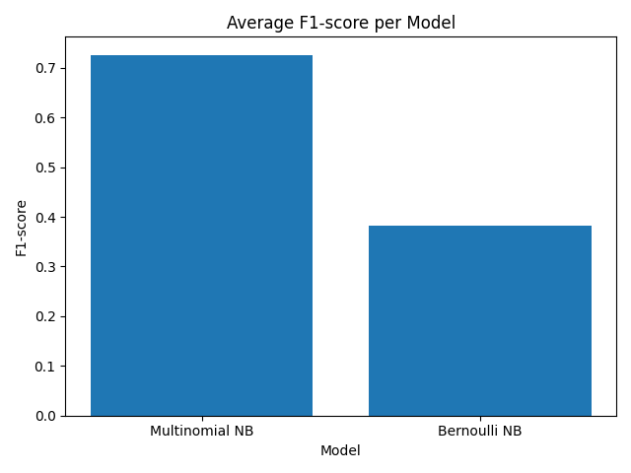
The performance of both models is shown in the figures below.
Figure 1

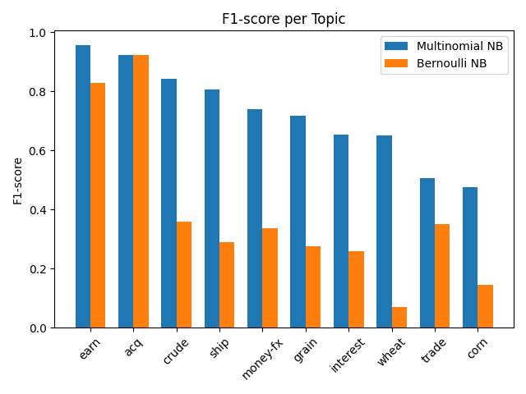
Figure 1 presents the average F1-score for both models. The Multinomial Naïve Bayes model clearly outperforms the Bernoulli model, achieving an average F1-score of approximately 0.73 compared to approximately 0.38 for the Bernoulli model.
Figure 2
Figure 2 shows the F1-score per topic. The Multinomial model performs better for nearly all topics, with especially large differences observed for topics such as crude, ship, and wheat. For some topics, such as acq, the performance of both models is more similar.
Overall, the Multinomial model consistently achieves higher performance across the majority of topics.

Discussion
The results show that the Multinomial Naïve Bayes model performs better than the Multivariate Bernoulli model. This can be explained by the fact that the Multinomial model uses word frequency information, while the Bernoulli model only considers whether a word is present or not. In text classification, the number of times a word appears can carry important information, which the Bernoulli model ignores.

These findings are consistent with the results reported by Andrew McCallum and Kamal Nigam, who show that the Multinomial model generally outperforms the Bernoulli model, with an average error reduction of approximately 27%.

However, the difference between the models is not always equally large. For some topics, the performance is relatively similar, which suggests that in certain cases the presence of words alone can already provide sufficient information for classification. This is also in line with the paper, which states that the Bernoulli model can perform competitively for smaller or simpler feature spaces.

Additionally, the paper shows that the Bernoulli model tends to perform better at small vocabulary sizes, while its performance decreases as the vocabulary size increases. In contrast, the Multinomial model remains stable or improves with larger vocabularies. Since this experiment uses a relatively large vocabulary, this further explains why the Multinomial model performs better.

It should also be noted that the original paper reports performance using precision-recall breakeven points, whereas this experiment uses F1-score. While these metrics are not identical, they are closely related, as both combine precision and recall into a single measure.

Reflection
Overall, the experiment was successfully implemented and produced results that are consistent with expectations from the literature. The pipeline is reproducible and the models behave as expected.
One of the main challenges was handling the multi-label nature of the dataset, which required transforming the problem into multiple binary classification tasks. Additionally, making preprocessing decisions, such as token filtering and vocabulary construction, required some interpretation, as the paper does not specify every detail explicitly.
The paper itself is relatively dense and not always straightforward to follow, which made it necessary to make certain assumptions during implementation. Despite this, the core methodology could be replicated, and the results align well with the findings presented in the paper.

Individual contribution and AI-use
Yvonne
- Contribution
  - Describing data
  - Description of pre-processing
  - Feature engineering
  - Model specification
- AI usage
  - Rewriting text
  - Implementing code from the internet
  - Getting ideas when I didn’t know how to work further. For example, I didn’t understand what the paper meant with ‘building a binary classifier for each of the 10 most populous classes’. AI was used to implement this in our own code.
  - Fixing errors. For example, I didn’t understand how to fix empty tokens. AI was used to understand how to remove these.
Jessie
- Contribution
  - Implemented ML pipeline: train/test split, binary labels for the top 10 topics, feature vectorization, and training both MultinomialNB and BernoulliNB models.
  - Calculated evaluation metrics and generated summary tables and plots.
  - Wrote model specification, training, evaluation, results, discussion, and reflection for the report.
- AI usage:
  - Used to add comments and docstrings to code.
  - Helped debug minor issues (e.g., handling empty tokens, fixing type warnings).
  - Used to clarify differences between MultinomialNB and BernoulliNB implementation details.
  - Suggested improvements in evaluation workflow and visualization.

